|  |  |
| --- | --- |
| Event 2 go  Project Specification | **Abstract**  Cross platform event management application designated for iOS, android and website users  **Prof: Jeff Fortuna**  Developers: Sanket Patel, Thomson Philip |

**Table of Contents**

Introduction1

Project Objectives1

User roles1

Functional requirements2

Success criteria2

Site Map3

Database Design4

Site Maintenance6

Project Timeline6

Budget 7

**Project Objectives**

**The following describes the project to be executed.**

|  |  |
| --- | --- |
| **Objective** | The main objective of this project is to create a functional event management app that will have cross platform support for iOS, android and web applications |
| **Goals Addressed** | The main goals for this project are:   * Working cross platform application features   + The users for iOS, android and web applications will be able to see real time event listing * Working user sign-up, log in & password reset   + The user will be able to sign up in the application     - The user will be signed up after a phone verification       * If the verification code entered is wrong the sign-up process will be revoked     - If the phone number is already registered, the sign up will be cancelled     - Error will show if the password entered has invalid characters     - Error will show if the confirm password value does not match     - Username will be checked for uniqueness   + Login will only be accepted thru registered username and password     - The logout option will only show if the user has logged in   + Password reset will be done via phone messaging     - The username for password reset should be registered in the database       * Error will be shown if the username is not registered * Working event creation, sign up, modification and deletion   + Users will be able to create events     - The event must have a name, location, event type and time       * Error will be shown if the values are missing     - The event end time should not be lower or equal to current time   + Users will be able to modify the events the user created     - The event end time should not be lower or equal to current time   + User will be able to delete an event the user created     - The event is automatically deleted if the current time passes the end time * Working user profiles   + The user profile will only contain the users name, image, age, occupation, and about me profile * The image, occupation and about me profile will be optional |
| **Planned Start Date** | January 9, 2018 |
| **Planned End Date** | April 2, 2018 |

**Functional Requirements**

**Use case:**

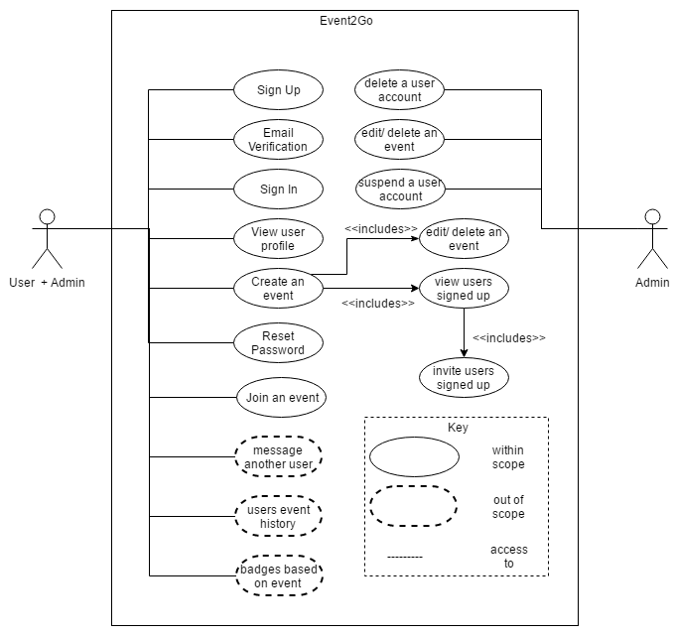

**State machine:**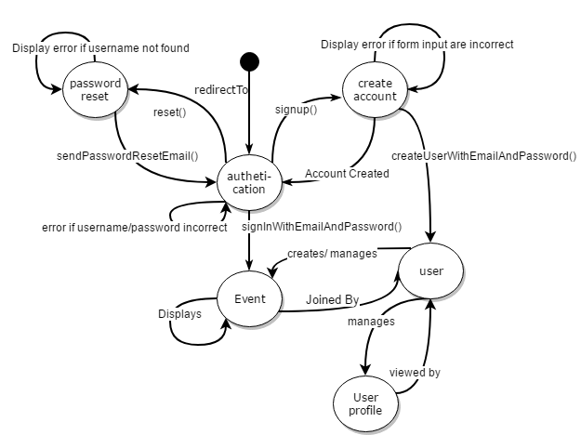

**Success Criteria**

The main success criteria considered for this application are:

* the cross-platform feature works as intended
* the user sign-up, log in and reset password functions work as intended
* the event creation, sign up and deletion features work as intended
* the user profiles work as intended

**Site Map**

**Sample site structure**

|  |  |
| --- | --- |
| * Login, SignUp and Forgot password screen: | |
|  |  |
|  | |
| * Menu Screen: | |
|  |  |
| * Managing Event | |
|  |  |
|  | |
| * User Profile | |
|  |  |

**Database Design**

* Entity Relationship Diagram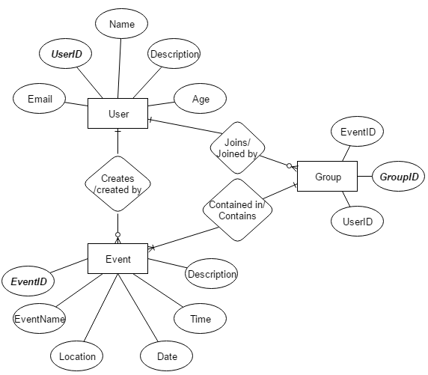
* Class Diagram

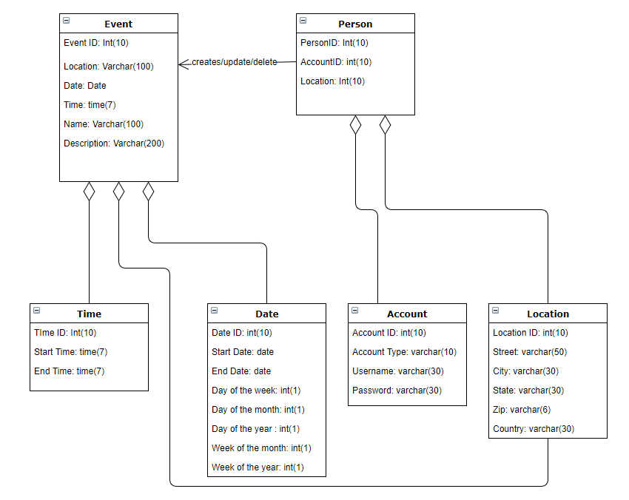

**Site Maintenance**

Phone gap would be used primarily to keep the testing servers up and the backend for the site will be maintained through firebase which has many features for example crash analytics and client data usage information.

**Project Timeline**

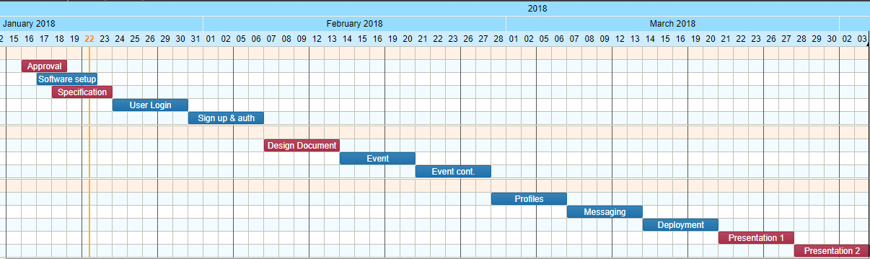 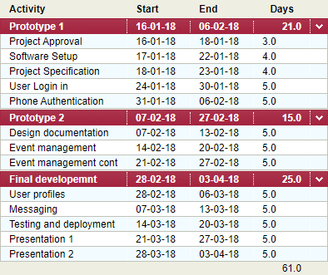

**Tech Stack**

|  |  |
| --- | --- |
| **PhoneGap** | Cloud based software used for cross platform applications |
| **Sublime/ Visual Studio** | Code editor |
| **Firebase** | Backend |
| **GitHub** | Version Control |